FUNDAMENTALS OF NETWORK SECURITY AND DEFENCE
SUMMATIVE ASSESSMENT MEMO

Module Code | 252901001-KM-02
NQF Level | 5
Credits | 12
Curriculum Code | 252901001
Qualification Title | Occupational Certificate: Cybersecurity Analyst
SAQA QUAL ID | 118986

Name
Contact Address
Telephone (H)
Telephone (W)
Facsimile
Cellular
E-mail

Note to the learner
This Learner Guide provides a comprehensive overview of the module. It is designed to improve the skills and knowledge of learners, and thus enabling them to effectively and efficiently complete specific tasks.
Entry Requirements

- NQF 4
Provider Accreditation Requirements for the Knowledge Module

Physical Requirements
- The provider must have lesson plans and structured learning material or provide learners with access to structured learning material that addresses all the topics in all the knowledge modules as well as the applied knowledge in the practical skills.
- QCTO/ MICT SETA requirements

Human Resource Requirements:
- Lecturer/learner ratio of 1:20 (Maximum)
- Qualification of lecturer (SME):
    - NQF 6 in industry recognised qualifications with 1 years’ experience in the IT industry
    - CYBERSECURITY vendor certification
- Assessors and moderators: accredited by the MICT SETA
Legal Requirements
- Legal (product) licences to use the software for learning and training
- OHS compliance certificate
- Ethical clearance (where necessary)
Module Purpose

The main focus of the learning in this knowledge module is to build an understanding of the principles and techniques applied in the editing and proofreading processes Network Security and Defence
Topic elements to be covered include
The learning will enable learners to demonstrate an understanding of:
- KM-02-KT01: Introduction to network security
- KM-02-KT02: Network risk and vulnerability management
- KM-02-KT03: Network defense fundamentals
- KM-02-KT04: Monitoring for breaches and attacks
- KM-02-KT05: Network incident response and management

Venue, Date and Time:
Consult your facilitator should there be any changes to the venue, date and/or time.
Refer to your timetable
Assessments

The only way to establish whether you are competent and have accomplished the learning outcomes is through continuous assessments. This assessment process involves interpreting evidence about your ability to perform certain tasks. You will be required to perform certain procedures and tasks during the training programmer and will be assessed on them to certify your competence.

This module includes assessments in the form of self-evaluations/activities and exercises. The exercises, activities and self-assessments will be done in pairs, groups or on your own. These exercises/activities or self-assessments (Learner workbook) must be handed to the facilitator. It will be added to your portfolio of evidence, which will be proof signed by your facilitator that you have successfully performed these tasks.

Listen carefully to the instructions of the facilitator and do the given activities in the time given to you.

Question
1
Explain the importance of protection of privacy and data
Why is Data Protection Important?


Data protection is important, since it prevents the information of an organization from fraudulent activities, hacking, phishing, and identity theft. Any organization that wants to work effectively need to ensure the safety of their information by implementing a data protection plan. As the amount of data stored and created increases, so does the importance of data protection. Data breaches and cyberattacks can cause devastating damages. Organizations need to proactively protect their data and regularly update their protective measures.
Ultimately, the key principle and importance of data protection is safeguarding and protecting data from different threats and under different circumstances. The following article elaborates more on data protection and its importance.
Key Elements of Data Protection
One very important data protection model is the CIA triad, where the three letters of the name represent the three elements of data protection: confidentiality, integrity, and availability. This model was developed to help individuals and organizations develop a holistic approach to data protection. The three elements are defined as follows:
- Confidentiality: The data is retrieved only by authorized operators with appropriate credentials.
- Integrity: All the data stored within an organization is reliable, precise, and not subject to any unjustified changes.
- Availability: The data stored is safely and readily available whenever needed.
The Type of Data That Requires Protection
Vital information of customers, such as names, addresses, emails, phone numbers, health information, or bank details, are all data that should be carefully stored and protected. Data protection gains special importance when the information concerns customers. If such information gets in the wrong hands, it can compromise people’s safety in many forms, including personal integrity, physical safety, and financial security. Stolen information can also be used to create fake profiles and commit fraud.
The implementation of a privacy information management system (PIMS) based on the requirements and guidance of ISO/IEC 27701 allows organizations to assess, treat, and reduce risks associated with the collection, maintenance, and processing of personal information.
If you wish to pursue a career in assisting organizations in this field, PECB offers a set of ISO/IEC 27701 training courses that provide the skills, methods, and tools needed to maintain a PIMS in compliance with ISO/IEC 27701.

Question
2
Evaluate network risk and vulnerability management
What Is A Network Vulnerability?

A network vulnerability is a weakness or flaw in software, hardware, or organizational processes, which when compromised by a threat, can result in a security breach.
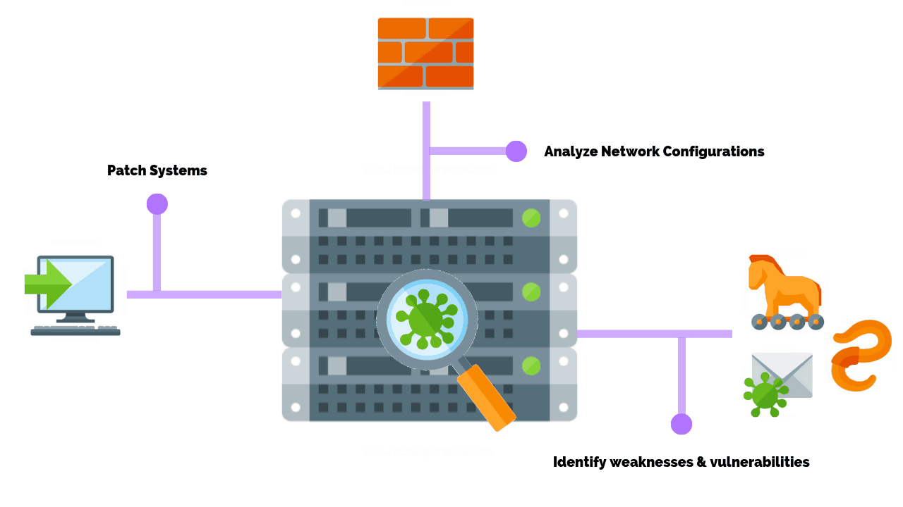
Nonphysical network vulnerabilities typically involve software or data. For example, an operating system (OS) might be vulnerable to network attacks if it’s not updated with the latest security patches. If left unpatched a virus could infect the OS, the host that it’s located on, and potentially the entire network.

Physical network vulnerabilities involve the physical protection of an asset such as locking a server in a rack closet or securing an entry point with a turnstile.
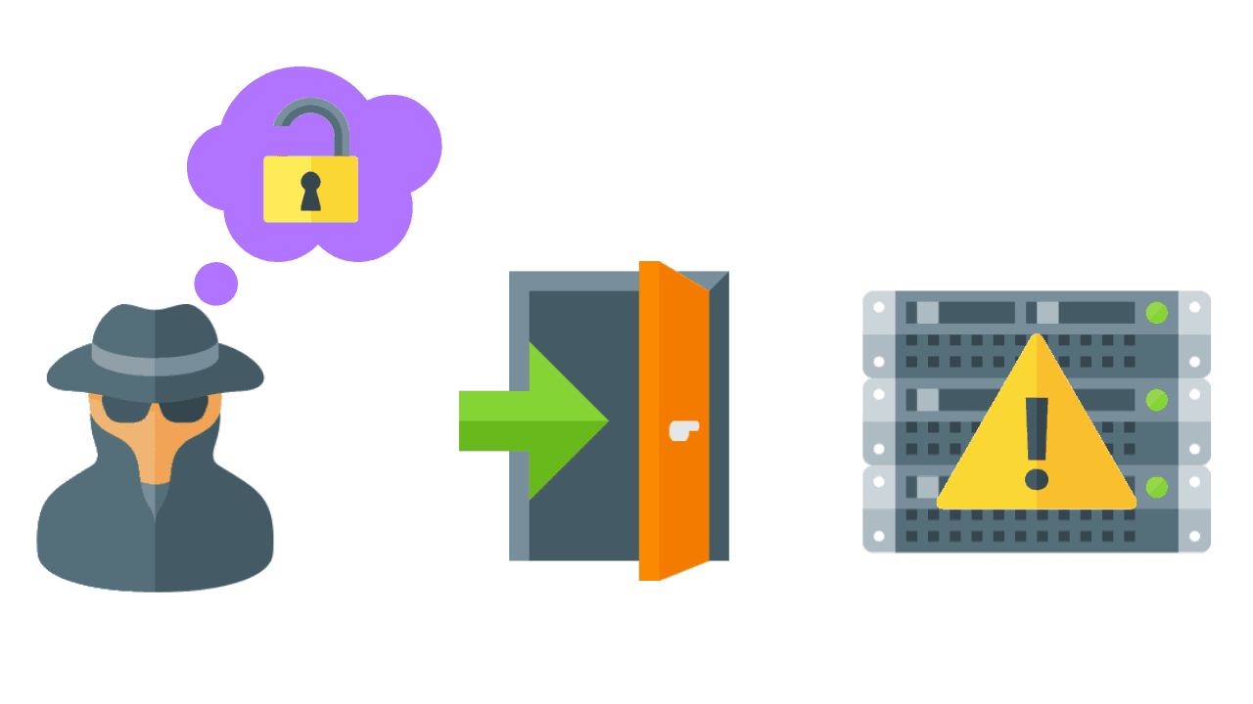
Servers have some of the strongest physical security controls in place as they contain valuable data and trade secrets or perform a revenue-generating function like a web server hosting an eCommerce site. Often stored in off-site data centers or in secure rooms, servers should be protected with personalized access cards and biometric scanners.

Prior to investing in security controls, a vulnerability risk assessment is performed to quantify the cost and acceptable loss of the equipment and its function. As with all things in cyber security it’s a balancing act of resources vs functionality that makes for the most practical solutions.

What Are The Different Types Of Network Vulnerabilities?

Network vulnerabilities come in many forms but the most common types are:

- Malware, short for malicious software, such as Trojans, viruses, and worms that are installed on a user’s machine or a host server.
- Social engineering attacks that fool users into giving up personal information such as a username or password.
- Outdated or unpatched software that exposes the systems running the application and potentially the entire network.
- Misconfigured firewalls / operating systems that allow or have default policies enabled.

It’s important that your network security team address these factors when assessing the overall security posture of your systems.

Question
3
Outline the procedures for monitoring of breaches and attacks
What is Network Traffic Analysis (NTA)?
Network traffic analysis (NTA) is a method of monitoring network availability and activity to identify anomalies, including security and operational issues. Common use cases for NTA include:
- Collecting a real-time and historical record of what’s happening on your network
- Detecting malware such as ransomware activity
- Detecting the use of vulnerable protocols and ciphers
- Troubleshooting a slow network
- Improving internal visibility and eliminating blind spots
Implementing a solution that can continuously monitor network traffic gives you the insight you need to optimize network performance, minimize your attack surface, enhance security, and improve the management of your resources. However, knowing how to monitor network traffic is not enough. It’s important to also consider the data sources for your network monitoring tool; two of the most common are flow data (acquired from devices like routers) and packet data (from SPAN, mirror ports, and network TAPs).
The key benefits of network traffic analysis
With the “it’s not if, it’s when” mindset regarding cyber-attacks today, it can feel overwhelming for security professionals to ensure that as much of an organization’s environment is covered as possible. The network is a critical element of their attack surface; gaining visibility into their network data provides one more area they can detect attacks and stop them early. Benefits of NTA include:
- Improved visibility into devices connecting to your network (e.g. IoT devices, healthcare visitors)
- Meet compliance requirements
- Troubleshoot operational and security issues
- Respond to investigations faster with rich detail and additional network context
A key step of setting up NTA is ensuring you’re collecting data from the right sources. Flow data is great if you are looking for traffic volumes and mapping the journey of a network packet from its origin to its destination. This level of information can help detect unauthorized WAN traffic and utilize network resources and performance, but it can lack rich detail and context to dig into cybersecurity issues.
Packet data extracted from network packets can help network managers understand how users are implementing/operating applications, track usage on WAN links, and monitor for suspicious malware or other security incidents. Deep packet inspection (DPI) tools provide 100% visibility over the network by transforming the raw metadata into a readable format and enabling network and security managers to drill down to the minutest detail.
The importance of network traffic analysis
Keeping a close eye on your network perimeter is always good practice. Even with strong firewalls in place, mistakes can happen and rogue traffic could get through. Users could also leverage methods such as tunneling, external anonymizers, and VPNs to get around firewall rules.
Additionally, the rise of ransomware as a common attack type in recent years makes network traffic monitoring even more critical. A network monitoring solution should be able to detect activity indicative of ransomware attacks via insecure protocols. Take WannaCry, for example, where attackers actively scanned for networks with TCP port 445 open, and then used a vulnerability in SMBv1 to access network file shares.
Remote Desktop Protocol (RDP) is another commonly targeted application. Make sure you block any inbound connection attempts on your firewall. Monitoring traffic inside your firewalls allows you to validate rules, gain valuable insight, and can also be used as a source of network traffic-based alerts.
Watch out for any suspicious activity associated with management protocols such as Telnet. Because Telnet is an unencrypted protocol, session traffic will reveal command line interface (CLI) command sequences appropriate for the make and model of the device. CLI strings may reveal login procedures, presentation of user credentials, commands to display boot or running configuration, copying files, and more. Be sure to check your network data for any devices running unencrypted management protocols, such as:
- Telnet
- Hypertext Transport Protocol (HTTP, port 80)
- Simple Network Management Protocol (SNMP, ports 161/162)
- Cisco Smart Install (SMI port 4786)

